**SMARTBRIDGE EDUCATIONAL SERVICES Pvt. Ltd**

**COMPUTER SCIENCE & ENGINEERING**

**Project on Topic**

profile based recruitment shortlist

**Submitted By**

**Name**

**VAISHNAVI**

**DEPARTMENT OF COMPUTER SCIENCE & ENGINEERING**

**VIVEKANANDA COLLEGE OF ENGINEERING & TECHNOLOGY**

[A Unit of Vivekananda Vidyavardhaka Sangha, Puttur (R)]

Affiliated to Visvesvaraya Technological University and Approved by AICTE New Delhi & Govt. of Karnataka

Nehru Nagara, Puttur – 574 203, DK, Karnataka, India

**July 2020**

**Table of Contents**

1. **INTRODUCTION 3**
   1. Overview 3
   2. Purpose 3

1. **LITERATURE SURVEY 4**

2.1 Existing problem 4

2.2 Proposed solution 4

1. **THEORITICAL ANALYSIS 5**
   1. Block Diagram 5
   2. Hardware /Software designing 5

1. **EXPERIMENTAL INVESTIGATION 6**
2. **FLOWCHART 7**
3. **RESULT 9**
4. **ADVANTAGES & DISADVANTAGES 11**
5. **APPLICATIONS 11**
6. **CONCLUSION 12**
7. **FUTURE SCOPE 12**
8. **BIBILOGRAPHY**  **13**

**APPENDIX**

1. **Source code**

**CHAPTER 1**

**INTRODUCTION**

SMARTBRIDGE is an EdTech organization with a vision to bridge the gap between academia & industry. Our outcome-based experimental learning programs on emerging technologies (Internet of Things, Machine Learning, Data Science, Artificial Intelligence, Robotics) are building skilled entry -level engineers, for the corporate world. SmartBridge is in mission to build technology communities in academia to encourage students towards innovation & entrepreneurship. I did “Profile based recruitment” project.

**1.1 Overview**

A AI machine which is useful for recruiting a right candidate for an empty position. Using a IBM Watson chat bot, build a model which is initially asking your name later than it will start the process by asking whether you are ready for the interview process. It will give you a round description like first round will be aptitude, second round will be technical etc.

**1.2 Purpose**

This bot will help you during the situation where you cannot take personal interviews. For example, current COVID-19 situation, where recruiters cannot take personal interviews directly and they have to search for alternative for recruitment so that time they can use this model. Initially, you have to create different intents used in bot. I have used intent like greeting which is having all the different kinds of greeting which candidate can greet the bot. You have to create intents like this. Then create a dialogue for chat bot, like can you please start by mentioning your name etc. Then try the bot if improvement required means do.

**CHAPTER 2**

**LITERATURE SURVEY**

**2.1 Existing problem**

It has been noted that in many situations it is hard to select the candidate, who is very much suitable for that position. It is also noted that direct interview process is a bit harder. So we can create a chat bot which will help to come out of this problem. Normal recruitment process is also lead to a problem like space, security issues, it may lead to some other problem.

**2.2 Proposed Solution**

Create a chat bot, which I will call it as “recruitment bot”, which will help you in recruitment process. Initially create intents like greetings, thank you etc. Then add dialogue to the bot as per their using order. Like Welcome, round1 etc. You have to give text which should initially be given by the chat bot, then it will wait for your reply. Once it will get reply from candidate then again it will continue its conversation. Then it will ask some interview questions that should be answered by the candidate. At the end it will give you the test result. In such a way you can recruit a candidate.

**CHAPTER 3**

**THEORITICAL ANALYSIS**

AI chat bot technique is used to build a profile-based recruitment shortlist. IBM Watson Assistant used to build the model.

**3.1 BLOCK DIAGRAM**

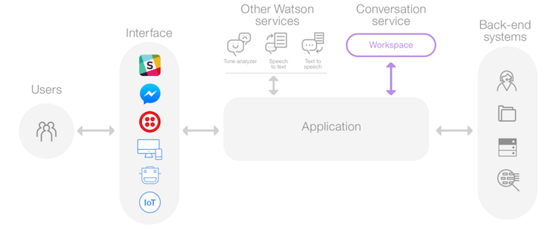

Fig 3.1

**3.2 HARDWARE/SOFTWARE DESIGNING**

I have designed a IBM Watson Assistant for build a chat bot.

Software Requirements:

IBM Watson Studio

GitHub

Zoho document write

**CHAPTER 4**

**EXPERIMENTAL INVESTIGATION**

There are some order to continue conversation here is the picture below.

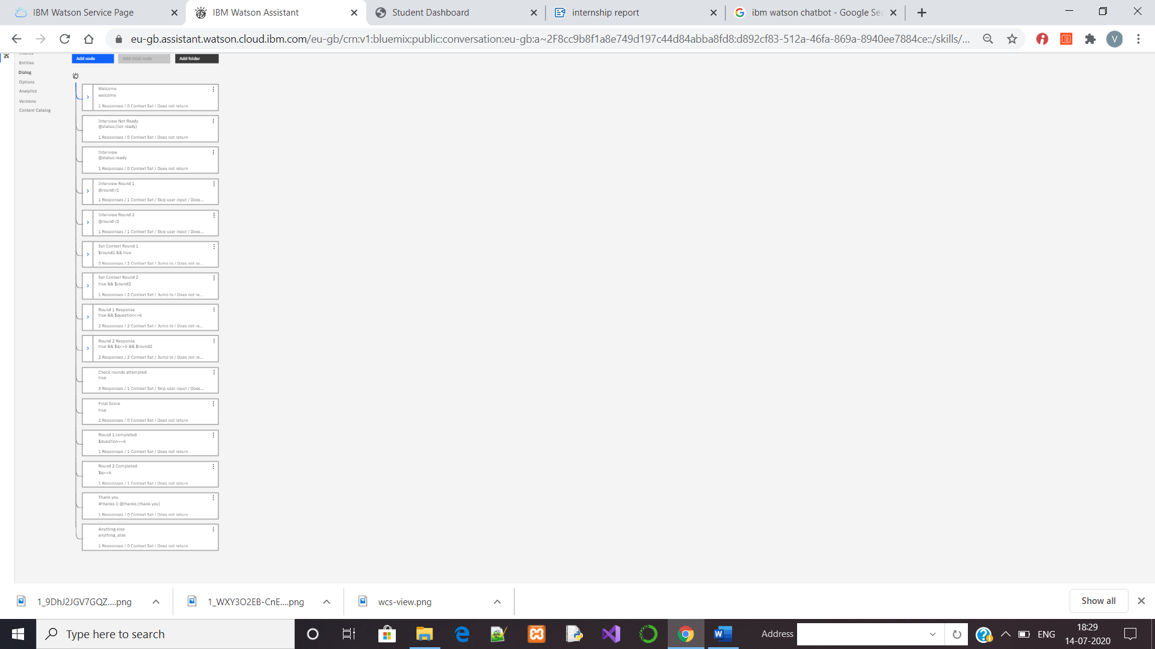

**CHAPTER 5**

**FLOW CHART**

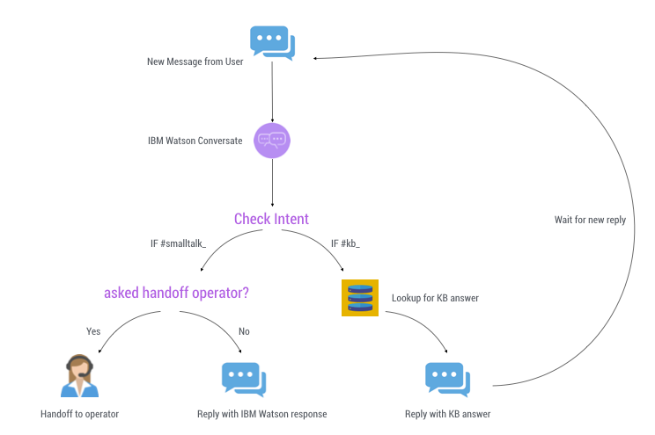

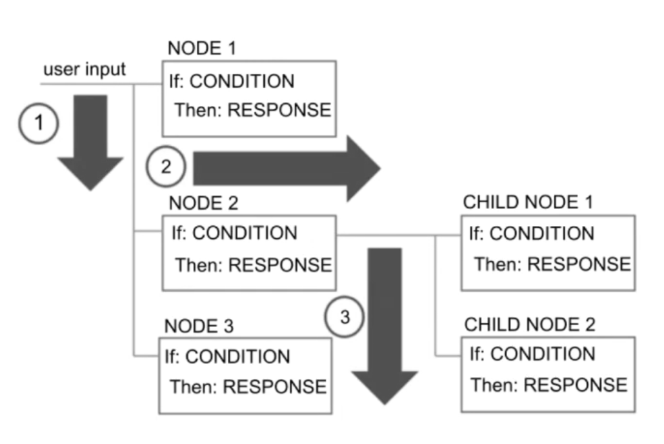

**CHAPTER 6**

**RESULT**

A IBM Watson Chat bot for profile based recruitment. In that creating various things like intents etc, bot is taking a interview of candidates by giving aptitude questions and technical test to check the logical thinking, technical skill etc. Then its giving result of the test. Based on that test it will hire a suitable candidate for given position.

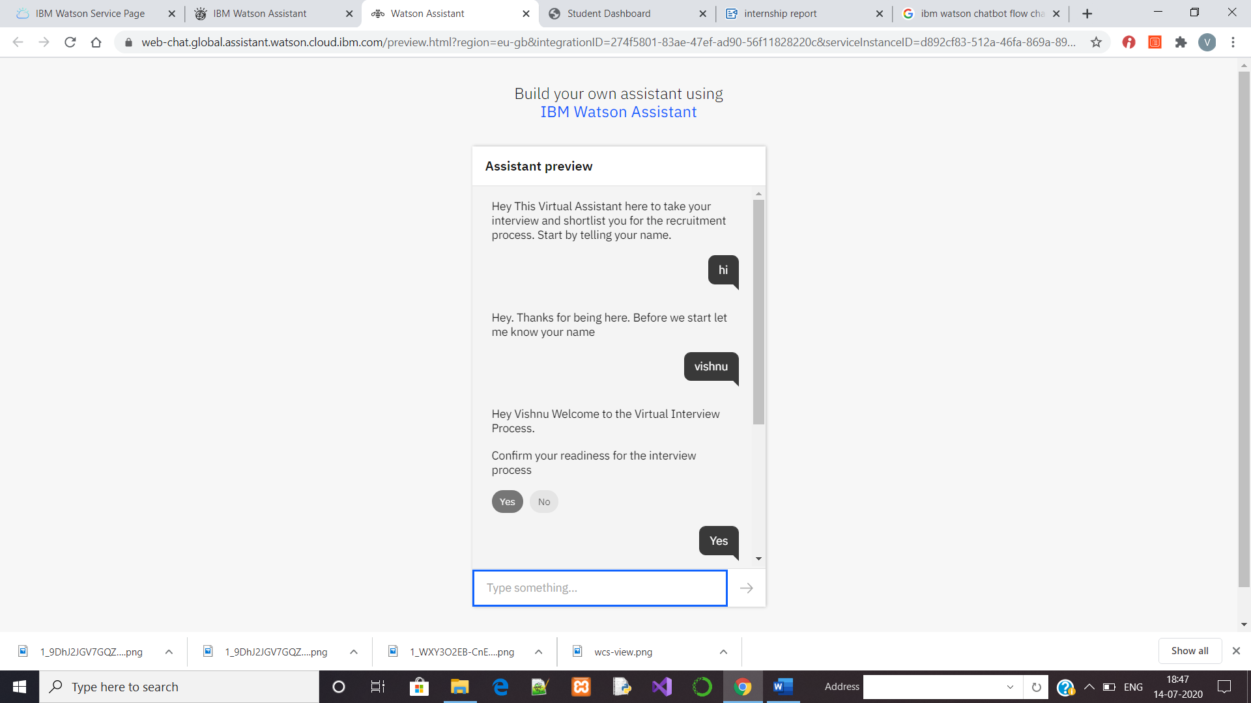

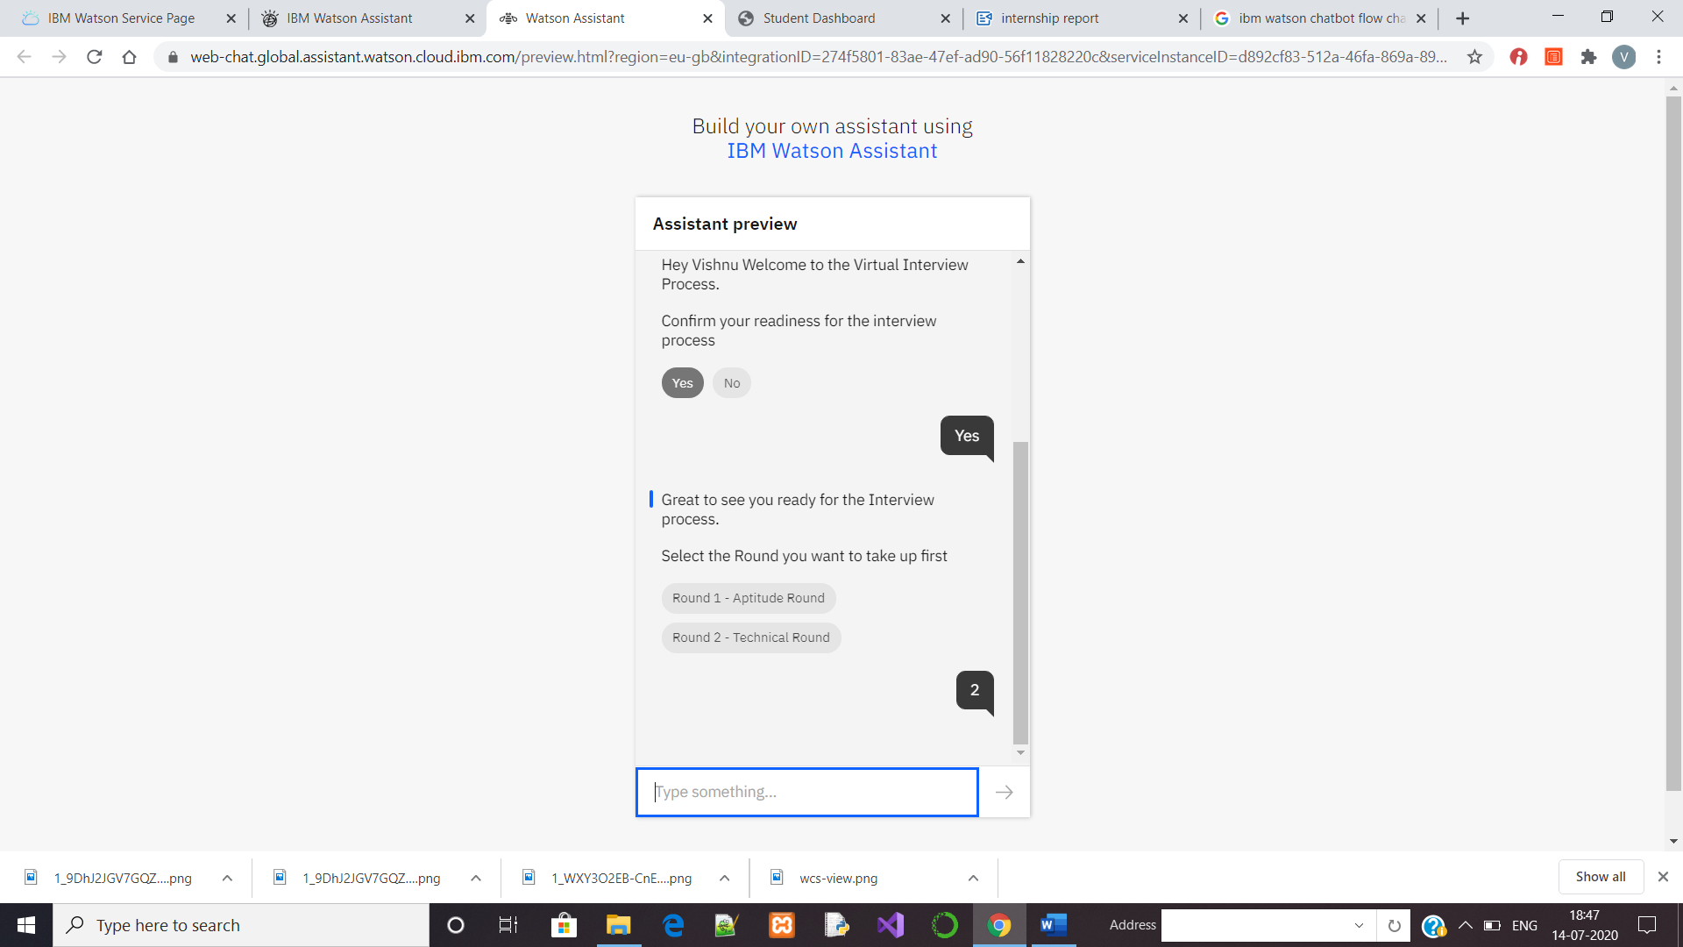

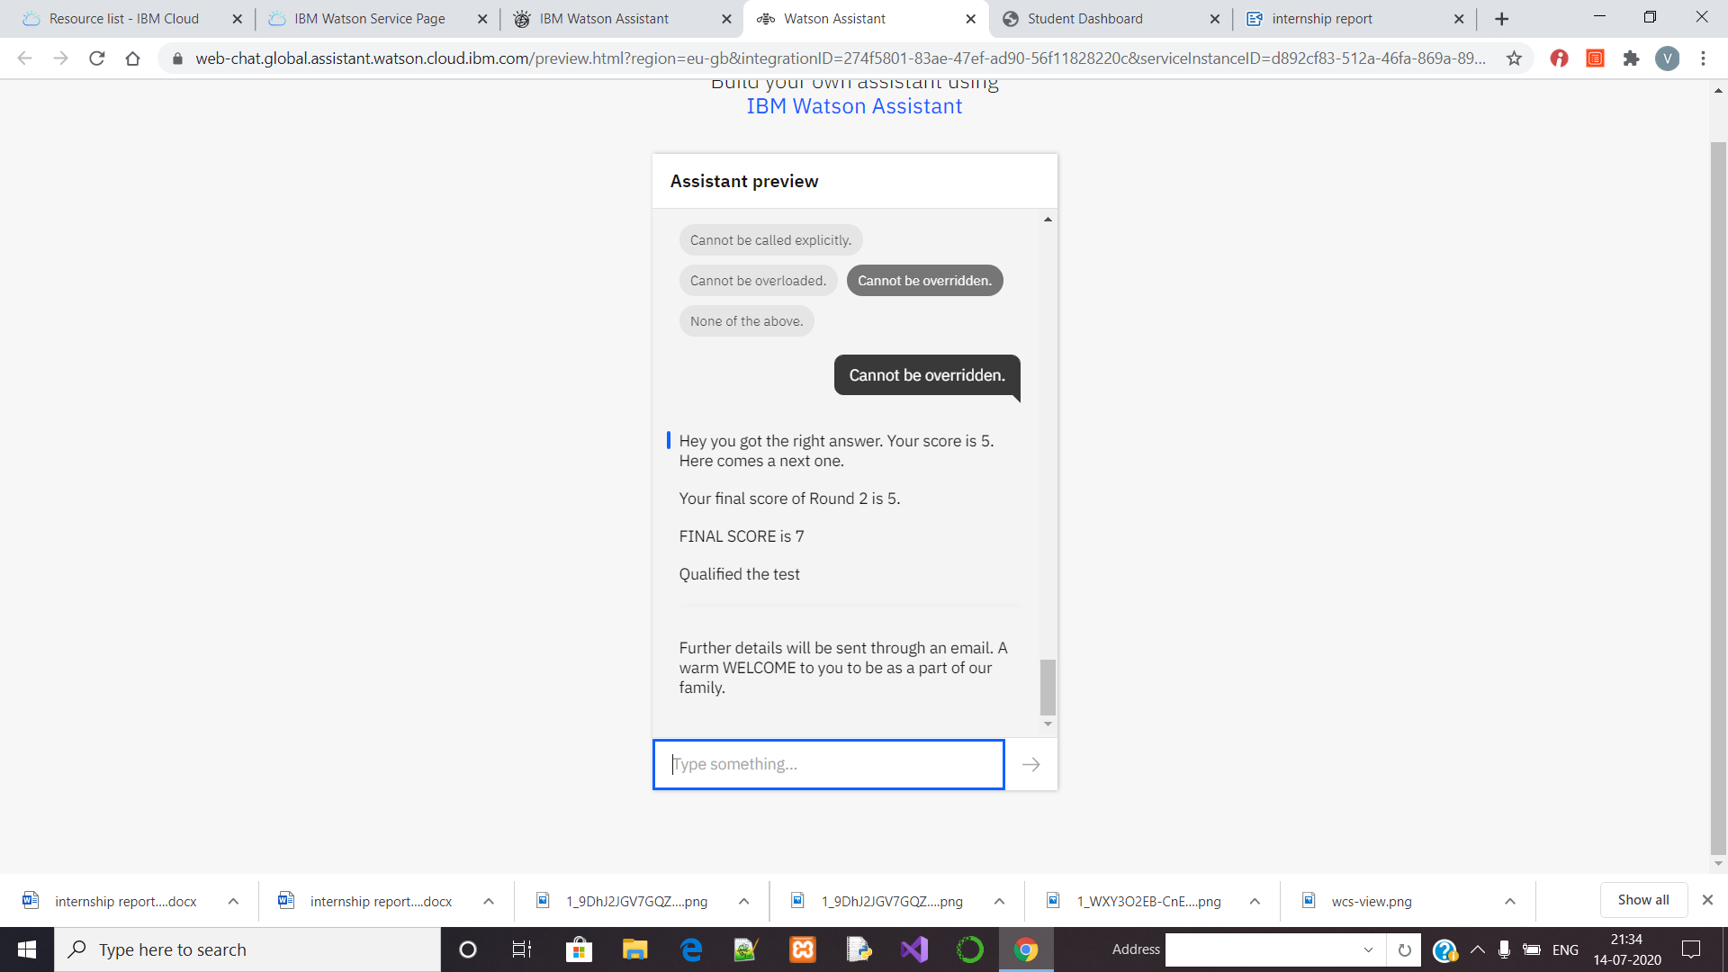

**CHAPTER 7**

**ADVANTAGES AND DISADVANTAGES**

**Advantages:**

1.Chatbots are like an HR assistant that provides help in the initial phase of recruitment.

2.Help Quickly schedule the interviews.

3.Provide a instant solution for user queries.

4.Keep talent pool engrossed and engaged with less effort.

**Disadvantages:**

1.Limited responses for customers.

2.Customer can become frustrated.

3.Complex chatbots could cost more.

**8.APPLICATION**

1. This can be used in MNC employee hiring process.

2. This model can also be used in competitive examination.

3. This model can be used in schools and colleges to take the students into college.

**9.CONCLUSION**

I had a great experience in various technologies. By doing this project I learned how to create a Node-Red flow, How I can use Watson Studio and Watson Assistant, how to create a instance for that, How can I use Watson Assistant etc. I also learned how can I build a Chat bot model using Watson assistant. This project helped me to learn numerous things, exposure in computer science.

**10.FUTURE SCOPE**

In future by adding new facilities like turning on webcam we can avoid the malicious practice etc. We can also add some more communication with chat bot to clear the candidate doubts etc. If chat bot is not able to give the satisfactory answers for the candidate, it can transform the control to the human assistance.

.

**12.BIBILOGRAPHY**

**APPENDIX**

1. Source Code Link: <https://web-chat.global.assistant.watson.cloud.ibm.com/preview.html?region=eu-gb&integrationID=274f5801-83ae-47ef-ad90-56f11828220c&serviceInstanceID=d892cf83-512a-46fa-869a-8940ee7884ce>
2. link for demonstration video:

https://drive.google.com/file/d/1ZKSeqa05pU6MnH0yHFR7e8AIFsehJ8kt/view? usp=sharing